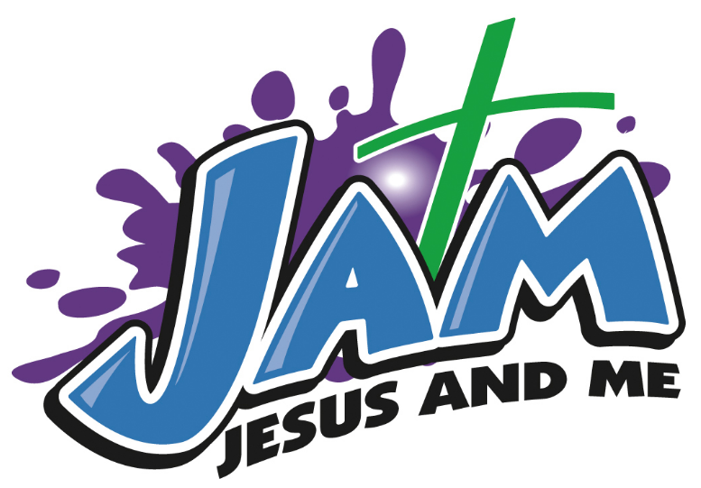

Kids Holiday Program
Tuesday 6th – Thursday 8th October
8.30am – 5pm

Who: School aged children 5-15 year old
What: Learning, Craft, Movies, Excursion (weather dependent and may be at extra cost), Arcade Games, Team Games, Lunch provided
Where: Gateway Baptist Church – 6 Jervois Street, Albert Park
Cost: $40/ child/day
$70/ 2 children/day
$100/ 3 children/day
Early Bird Special: Book before 25th September - $100/child/3 days $180/ 2 children/3 days $250/ 3 children/ 3 days
Child Protection and COVID safe environment

